SRM INSTITUTE OF

SCIENCE &TECHNOLOGY

Kattankulathur

Chennai

|  |  |
| --- | --- |
| Name | * **GAURAV GUPTA** |
| Subject | * Advanced Programming practice |
| Section | * W2 |
| Roll No. | * RA2211026010284 |
| Title | * Assignment   week 12 |

**Assignment**

**Week 12**

**Q1) Write a Python program to create an NFA that accepts strings containing only the letter 'a'.**

**CODE:**

**from automata.fa.nfa import NFA**

**nfa=NFA(**

**states={'q0','q1'},**

**input_symbols={'a'},**

**transitions={**

**'q0':{'a':{'q1'}},**

**'q1':{'a':{'q1'}}**

**},**

**initial_state='q0',**

**final_states={'q1'}**

**)**

**input_string = input("Enter a string: ")**

**if nfa.accepts_input(input_string):**

**print("Accepted")**

**else:**

**print("Rejected")**

**Output:**

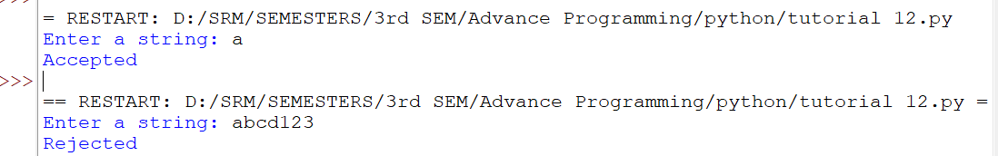

**Q2) Create a Python function to check if a given string is accepted by an NFA that recognizes the pattern "ab|ba" (either "ab" or "ba").**

**CODE:**

**from automata.fa.nfa import NFA**

**nfa=NFA(**

**states={'q0','q1','q2'},**

**input_symbols={'a','b'},**

**transitions={**

**'q0':{'a':{'q1'},'b':{'q2'}},**

**'q1':{'b':{'q2'}},**

**'q2':{'a':{'q1'}}**

**},**

**initial_state='q0',**

**final_states={'q1','q2'}**

**)**

**input_string = input("Enter a string: ")**

**if nfa.accepts_input(input_string):**

**print("Accepted")**

**else:**

**print("Rejected")**

**Output:**

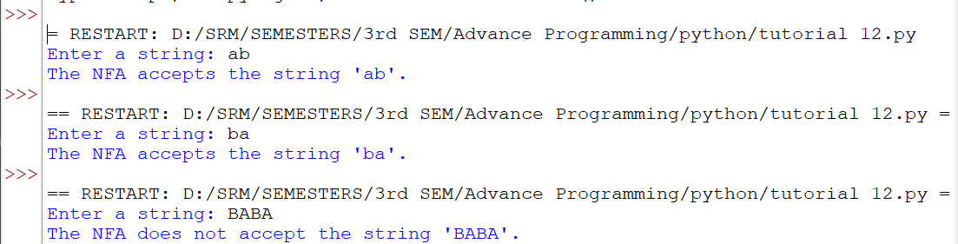

**Q3) Implement a Python script that converts a simple NFA into a DFA with two states.**

**CODE:**

**# Define the NFA transitions**

**nfa_transitions = {**

**('q0', 'a'): {'q1'},**

**('q1', 'b'): {'q2'},**

**('q2', 'a'): {'q1'},**

**('q0', ''): {'q2'}**

**}**

**# Initialize DFA variables**

**dfa_states = set()**

**dfa_transitions = {}**

**dfa_initial = ('q0',)**

**dfa_final = set()**

**# Initialize a queue for processing states**

**queue = [dfa_initial]**

**while queue:**

**current_states = queue.pop()**

**dfa_states.add(current_states)**

**for symbol in {'a', 'b'}:**

**next_states = set()**

**for nfa_state in current_states:**

**epsilon_transition = nfa_transitions.get((nfa_state, ''))**

**if epsilon_transition:**

**next_states.update(epsilon_transition)**

**symbol_transition = nfa_transitions.get((nfa_state, symbol))**

**if symbol_transition:**

**next_states.update(symbol_transition)**

**next_states = tuple(sorted(next_states))**

**dfa_transitions[(current_states, symbol)] = next_states**

**if next_states not in dfa_states:**

**queue.append(next_states)**

**# Identify final states**

**for dfa_state in dfa_states:**

**for nfa_state in dfa_state:**

**if nfa_state in {'q1', 'q2'}:**

**dfa_final.add(dfa_state)**

**# Print the DFA**

**print("DFA States:", dfa_states)**

**print("DFA Transitions:", dfa_transitions)**

**print("DFA Initial State:", dfa_initial)**

**print("DFA Final States:", dfa_final)**

**Output:**

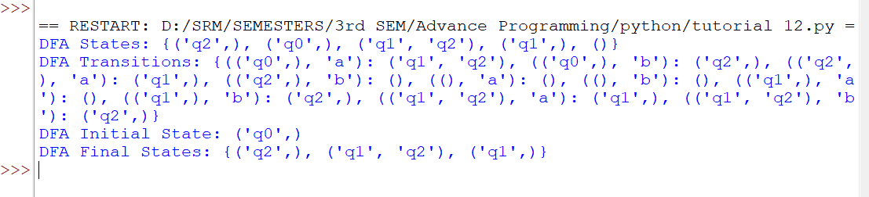

**Q4) Write a Python program to construct a DFA that accepts binary strings ending in '01'.**

**CODE:**

**# Get the input binary string from the user**

**input_string = input("Enter a binary string: ")**

**# Initialize current state**

**current_state = 0**

**# Iterate through characters in the input string**

**for char in input_string:**

**if current_state == 0 and char == '0':**

**current_state = 1**

**elif current_state == 1 and char == '1':**

**current_state = 2**

**else:**

**current_state = 0**

**# Check if the last two characters are '01'**

**if input_string[-2:] == '01':**

**print("Accepted: The string ends with '01'.")**

**else:**

**print("Rejected: The string does not end with '01'.")**

**Output:**

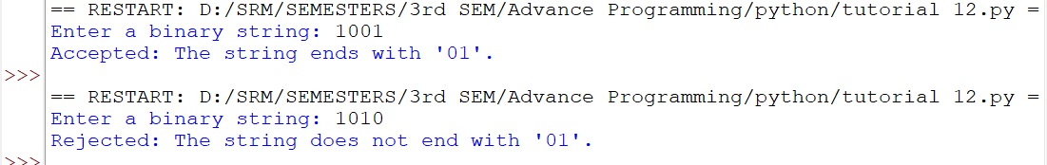

**Q5) Develop a Python function that takes an NFA and returns the set of states that can be reached from a given state on a specific input symbol.**

**CODE:  
  
# Define the NFA properties**

**nfa = {**

**'states': {'q0', 'q1', 'q2'},**

**'alphabet': {'a', 'b'},**

**'transitions': {**

**'q0': {'a': {'q1'}, 'b': {'q2'}},**

**'q1': {'a': {'q1'}, 'b': {'q2'}},**

**'q2': {'a': {'q2'}, 'b': {'q2'}}**

**},**

**'initial_state': 'q0',**

**'final_states': {'q2'}**

**}**

**# Get input state and symbol from user**

**state = input("Enter a state: ")**

**symbol = input("Enter an input symbol: ")**

**# Find reachable states**

**reachable_states = set()**

**for transition_state, transitions in nfa['transitions'].items():**

**if transition_state == state and symbol in transitions:**

**reachable_states.update(transitions[symbol])**

**# Print reachable states**

**print(f"States reachable from '{state}' on input '{symbol}':", reachable_states)**

**Output:**

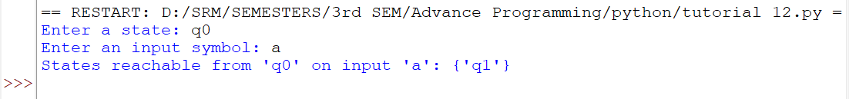

**Q6) Create a Python script to minimize a simple DFA with three states by merging equivalent states.**

**CODE:**

**# Define the DFA properties**

**dfa = {**

**'states': ['q0', 'q1', 'q2'],**

**'alphabet': {'0', '1'},**

**'transitions': {**

**'q0': {'0': 'q0', '1': 'q1'},**

**'q1': {'0': 'q2', '1': 'q1'},**

**'q2': {'0': 'q0', '1': 'q1'},**

**},**

**'initial_state': 'q0',**

**'final_states': ['q2']**

**}**

**# Step 1: Split states into two sets - final states and non-final states**

**final_states = set(dfa['final_states'])**

**non_final_states = set(dfa['states']) - final_states**

**# Step 2: Initialize partition with the two sets**

**partition = [final_states, non_final_states]**

**# Step 3: Refine the partition using the transitions**

**while True:**

**new_partition = []**

**for group in partition:**

**new_groups = []**

**for symbol in dfa['alphabet']:**

**target_states = set()**

**for state in group:**

**target_state = dfa['transitions'][state][symbol]**

**target_states.add(target_state)**

**for subgroup in new_groups:**

**if target_states == subgroup:**

**subgroup.update(group)**

**break**

**else:**

**new_groups.append(target_states)**

**if len(new_groups) > 1:**

**break**

**else:**

**new_groups = [group]**

**new_partition.extend(new_groups)**

**if new_partition == partition:**

**break**

**partition = new_partition**

**# Step 4: Build the new DFA**

**new_states = []**

**new_transitions = {}**

**for group in partition:**

**new_state = ','.join(sorted(group))**

**new_states.append(new_state)**

**for state in group:**

**if state in final_states:**

**final_state = new_state**

**break**

**else:**

**final_state = None**

**new_transitions[new_state] = {}**

**for symbol in dfa['alphabet']:**

**target_states = set()**

**for state in group:**

**target_state = dfa['transitions'][state][symbol]**

**target_states.add(target_state)**

**for subgroup in partition:**

**if target_states == subgroup:**

**new_transitions[new_state][symbol] = ','.join(sorted(subgroup))**

**break**

**minimized_dfa = {**

**'states': new_states,**

**'alphabet': dfa['alphabet'],**

**'transitions': new_transitions,**

**'initial_state': ','.join(sorted(partition[0])),**

**'final_states': [final_state] if final_state is not None else [],**

**}**

**# Print the minimized DFA**

**print(minimized_dfa)**

**Output:**

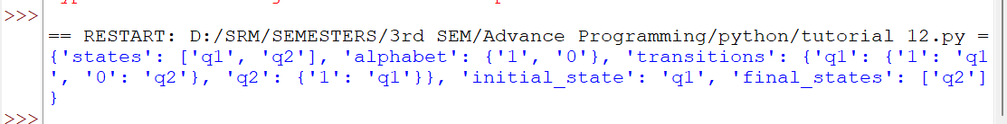

**Q7) Implement a Python function that checks if a given string is accepted by a DFA that recognizes the pattern "ab*c".**

**CODE:**

**# Define the DFA properties**

**dfa = {**

**'states': {'q0', 'q1', 'q2', 'q3'},**

**'alphabet': {'a', 'b', 'c'},**

**'transitions': {**

**'q0': {'a': 'q1'},**

**'q1': {'b': 'q2'},**

**'q2': {'b': 'q2', 'c': 'q3'},**

**'q3': {}**

**},**

**'initial_state': 'q0',**

**'final_states': {'q3'}**

**}**

**# Get input string from user**

**input_string = input("Enter a string: ")**

**# Initialize current state**

**current_state = dfa['initial_state']**

**# Iterate through characters in the input string**

**for symbol in input_string:**

**if symbol not in dfa['alphabet']:**

**print(f"Invalid symbol '{symbol}' in the input.")**

**break**

**current_state = dfa['transitions'][current_state].get(symbol)**

**if current_state is None:**

**break**

**# Check if the current state is a final state**

**if current_state in dfa['final_states']:**

**print("Accepted")**

**else:**

**print("Rejected")**

**Output:**

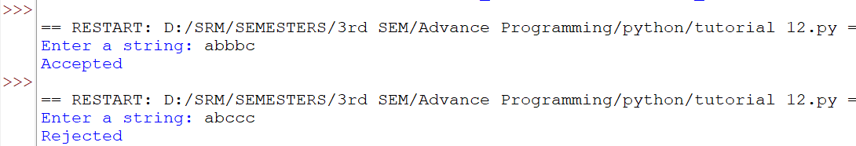

**Q8) Write a Python program to create an NFA that accepts strings with an odd number of '1's.**

**CODE:**

**# Define the NFA properties**

**nfa = {**

**'states': {'q0', 'q1'},**

**'input_symbols': {'0', '1'},**

**'transitions': {**

**'q0': {'0': {'q0'}, '1': {'q0', 'q1'}},**

**'q1': {'0': {'q1'}, '1': {'q1'}}**

**},**

**'initial_state': 'q0',**

**'final_states': {'q1'}**

**}**

**# Get input string from user**

**input_string = input("Enter a string: ")**

**# Initialize current states as a set with the initial state**

**current_states = {'q0'}**

**# Iterate through characters in the input string**

**for symbol in input_string:**

**if symbol not in nfa['input_symbols']:**

**print(f"Invalid symbol '{symbol}' in the input.")**

**break**

**next_states = set()**

**for state in current_states:**

**next_states.update(nfa['transitions'][state].get(symbol, set()))**

**current_states = next_states**

**# Check if the final state is in the set of current states and the input string has an odd number of '1's**

**if 'q1' in current_states and input_string.count('1') % 2 != 0:**

**print("Accepted")**

**else:**

**print("Rejected")**

**Output:**

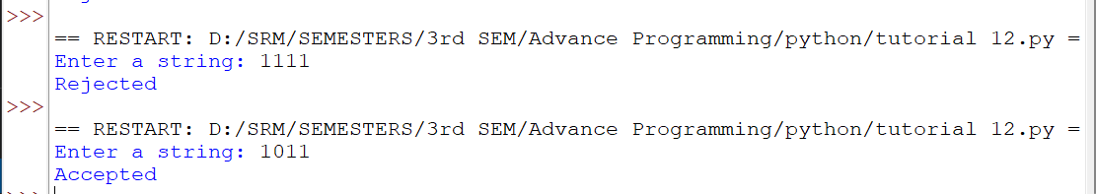

**Q9) Develop a Python function that converts a simple regular expression like "a(b|c)*" into an equivalent NFA.**

**CODE:**

**# Define the NFA properties**

**nfa = {**

**'states': {'q0', 'q1', 'q2', 'q3'},**

**'input_symbols': {'a', 'b', 'c'},**

**'transitions': {**

**'q0': {'a': {'q1'}},**

**'q1': {'b': {'q2', 'q1'}, 'c': {'q2', 'q1'}},**

**'q2': {'b': {'q2'}, 'c': {'q2'}},**

**'q3': {}**

**},**

**'initial_state': 'q0',**

**'final_states': {'q2'}**

**}**

**# Get input string from user**

**input_string = input("Enter a string: ")**

**# Initialize current states as a set with the initial state**

**current_states = {'q0'}**

**# Iterate through characters in the input string**

**for symbol in input_string:**

**if symbol not in nfa['input_symbols']:**

**print(f"Invalid symbol '{symbol}' in the input.")**

**break**

**next_states = set()**

**for state in current_states:**

**next_states.update(nfa['transitions'][state].get(symbol, set()))**

**current_states = next_states**

**# Check if the final state is in the set of current states**

**if 'q2' in current_states:**

**print("Accepted")**

**else:**

**print("Rejected")**

**Output:**

